STM32 Blue Pill board

The STM32 Blue Pill board is a small, low-cost microcontroller board based on the STM32F103C8T6 microcontroller. It is designed to be used as a development platform for hobbyists, students, and engineers who are interested in learning about microcontroller programming.

The board features an STM32F103C8T6 microcontroller with a 72 MHz Arm Cortex-M3 CPU, 64 KB of flash memory, and 20 KB of SRAM. It also includes a USB connector for programming and debugging, a 5V voltage regulator, and a set of general-purpose I/O pins.

The Blue Pill board is compatible with various development environments, including the Arduino Integrated Development Environment (IDE), the STM32CubeIDE, and the System Workbench for STM32.

In order to use the Blue Pill board, you will need to connect it to a computer using a USB cable, install the necessary software and drivers, and write and upload code to the board using a development environment. You can find many tutorials and projects online to help you get started with the STM32 Blue Pill board.

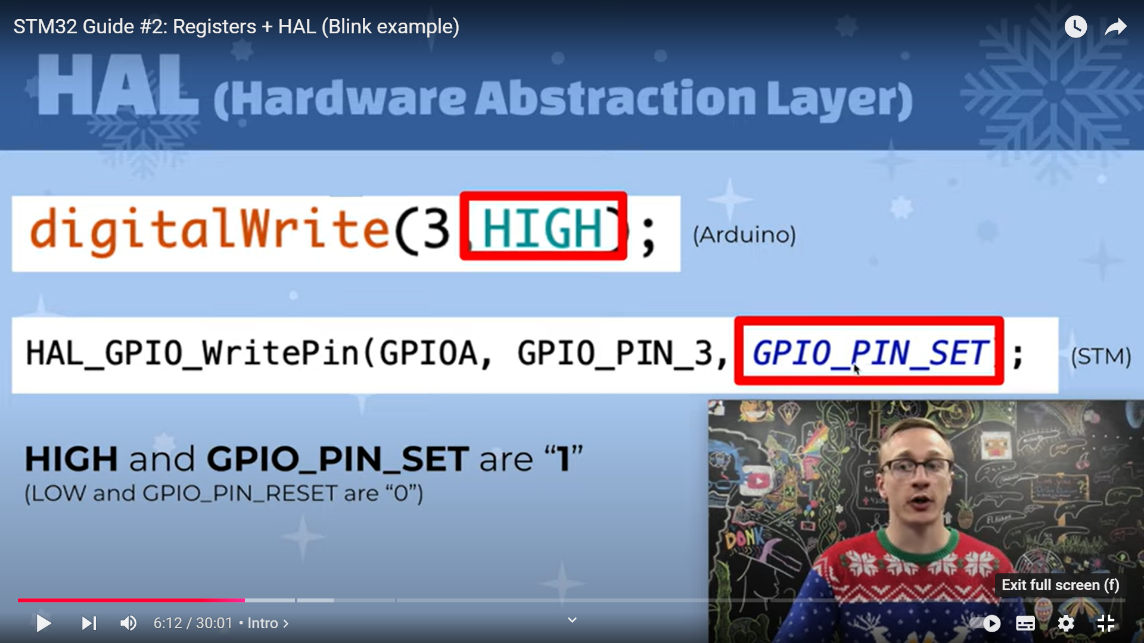

ST-Link

ST-Link is a small in-circuit debugger and programmer for the STM32 microcontroller, manufactured by STMicroelectronics. It is a low-cost alternative to other debugging and programming tools, making it an ideal choice for hobbyists, students, and engineers.

The ST-Link device connects to a computer via USB and provides a bridge between the computer and the microcontroller. It can be used to upload code to the microcontroller, debug code as it runs, and monitor the state of its pins.

https://freeelectron.ro/installing-st-link-v2-to-flash-stm32-targets-on-linux/

SWIO pin

SWDIO (Serial Wire Debug Input/Output) is a pin on the ST-Link device that is used for debugging and programming the STM32 microcontroller. It is part of the Serial Wire Debug (SWD) interface, which is a two-pin alternative to the JTAG (Joint Test Action Group) interface.

The SWDIO pin is used to transfer data between the ST-Link device and the microcontroller, allowing you to upload code, debug code as it runs, and monitor the state of the microcontroller's pins.

The SWDIO pin should be connected to the SWDIO pin on the STM32 microcontroller, along with the SWCLK (Serial Wire Debug Clock) pin, in order to establish a connection between the ST-Link and the microcontroller.

HAL_GPIO

HAL_GPIO (Hardware Abstraction Layer General Purpose Input/Output) is a software library provided by STMicroelectronics for the STM32 microcontroller series. It is part of the STM32CubeF1 firmware package and provides a standard interface for controlling the general-purpose input/output (GPIO) pins on the microcontroller.

The HAL_GPIO library provides a set of functions that simplify the process of configuring and controlling the GPIO pins. This includes functions for setting the pin mode, reading the pin state, writing to the pin, and configuring the pin interrupt.

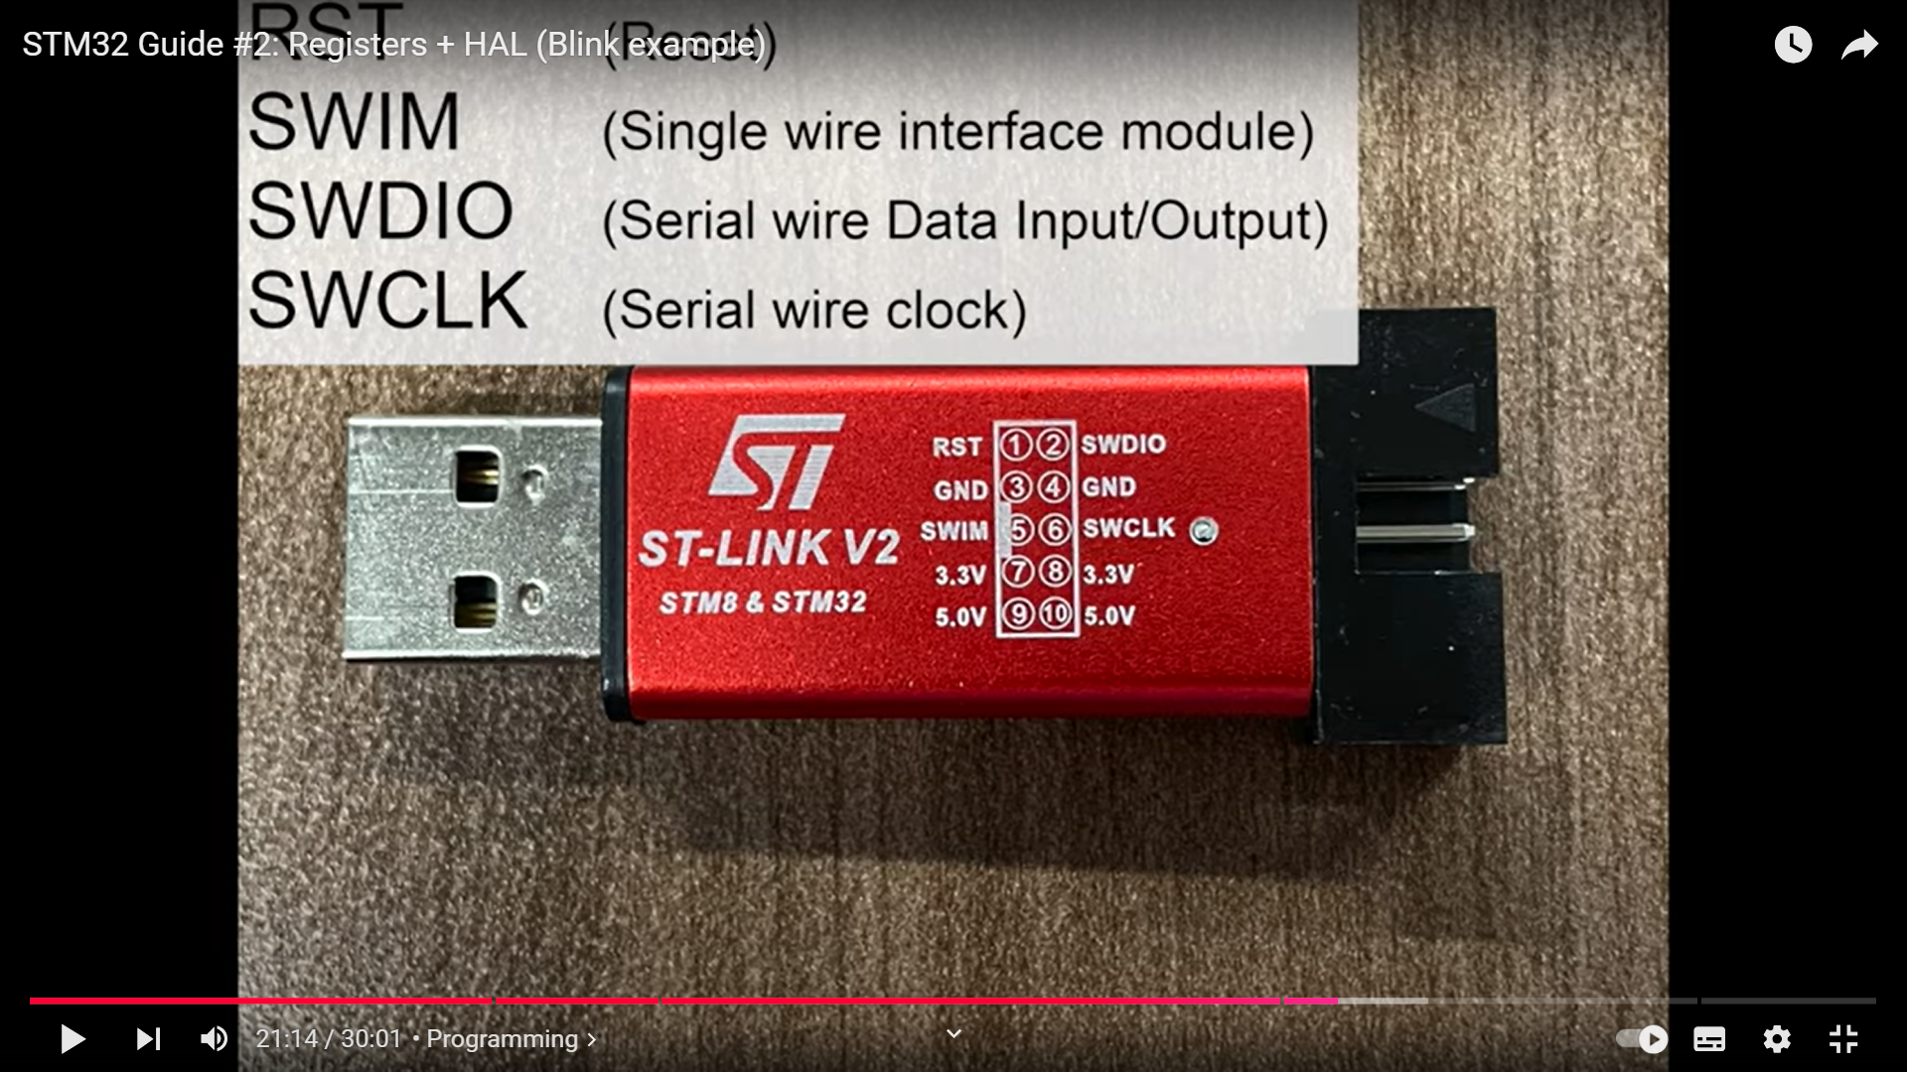

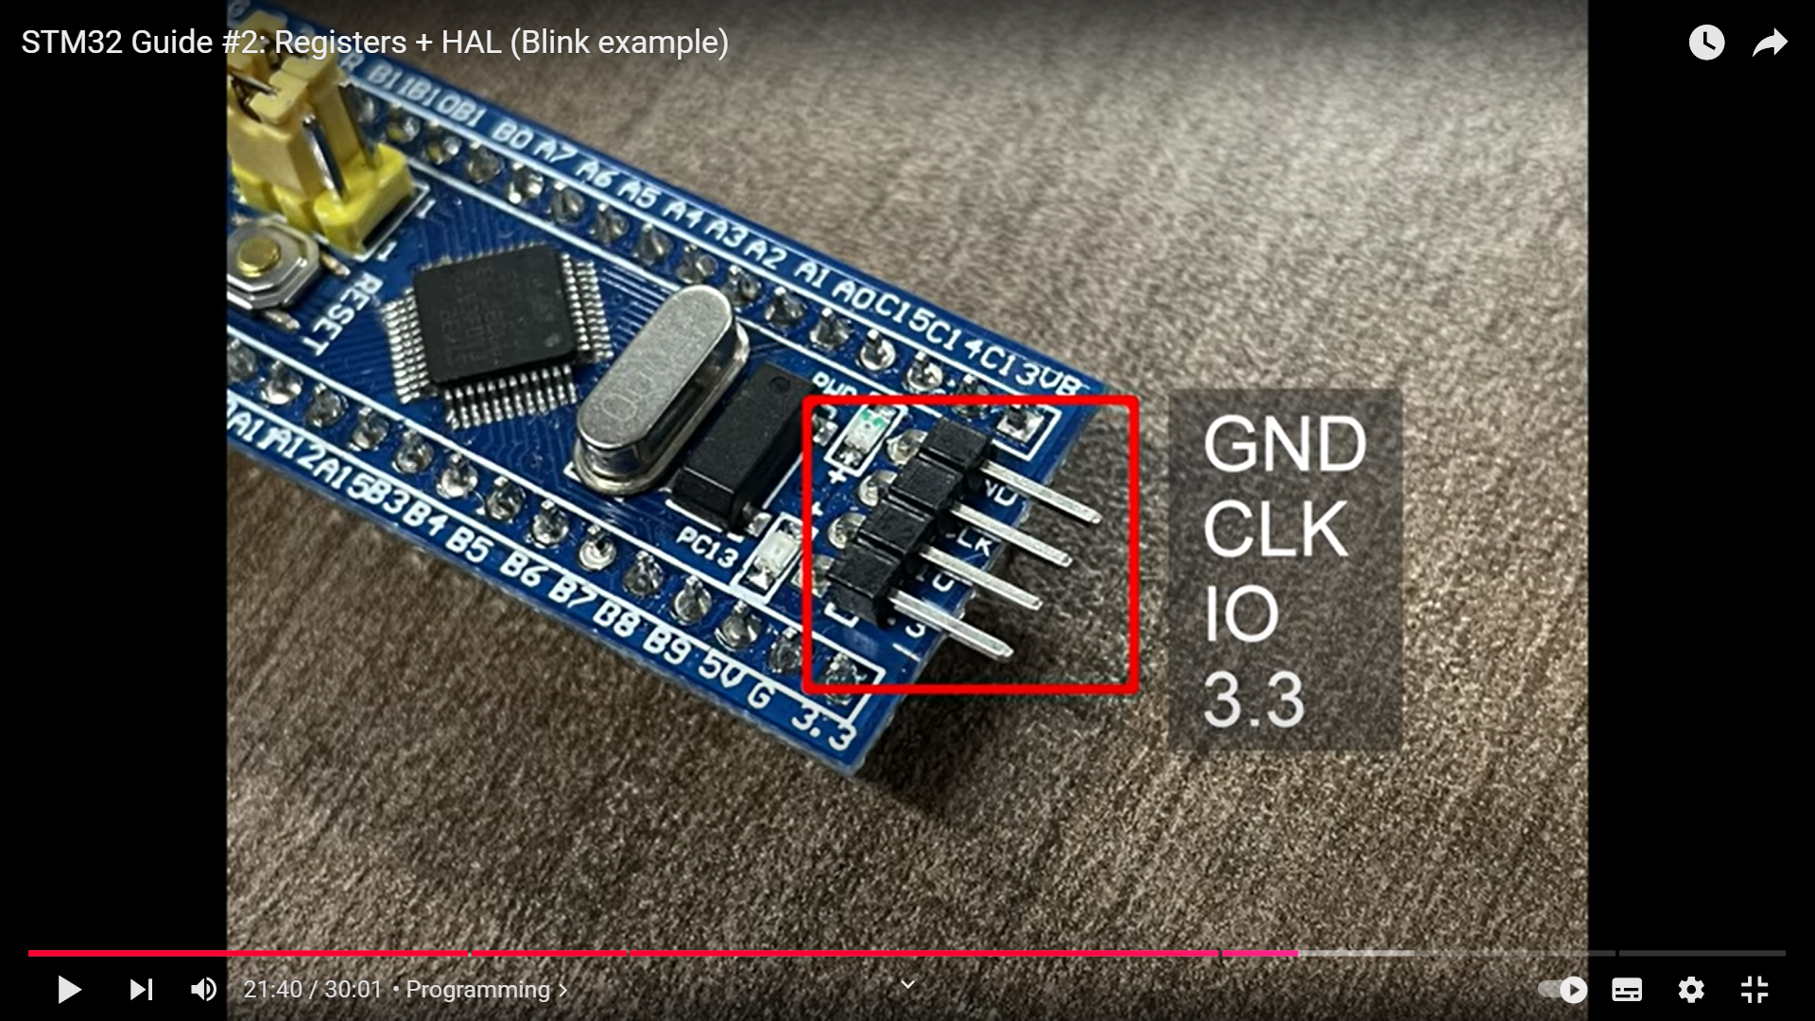

Nucleo pinout

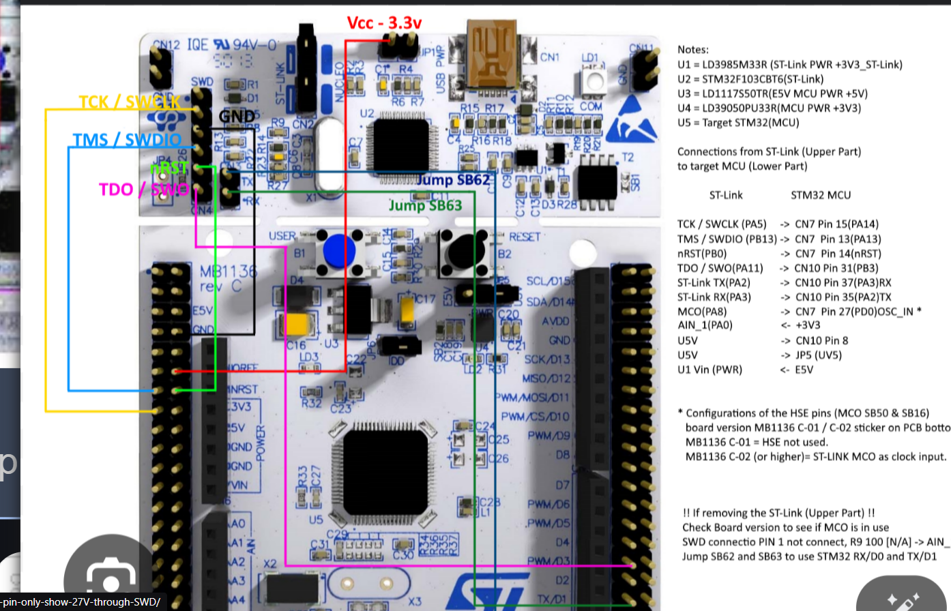



**DUTY CYCLE**

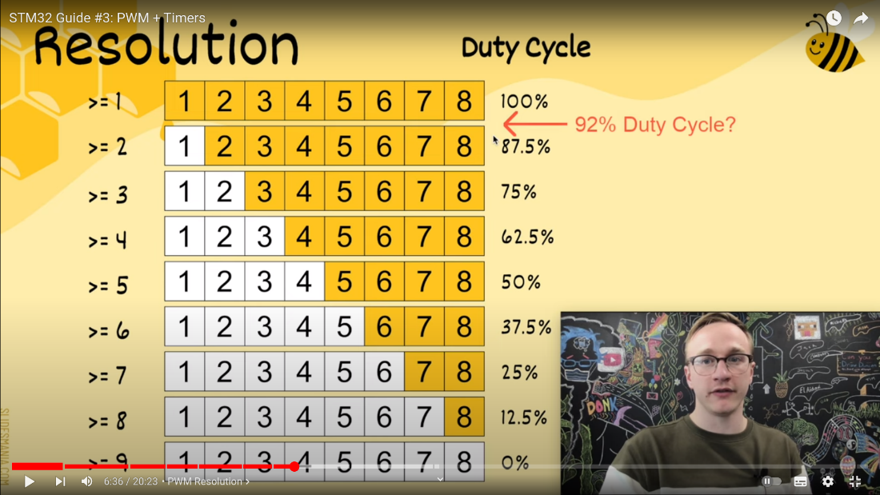

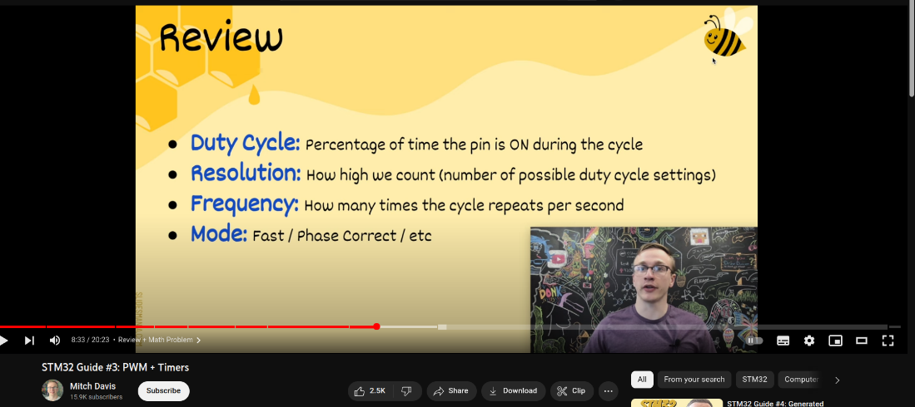

MATH TIME





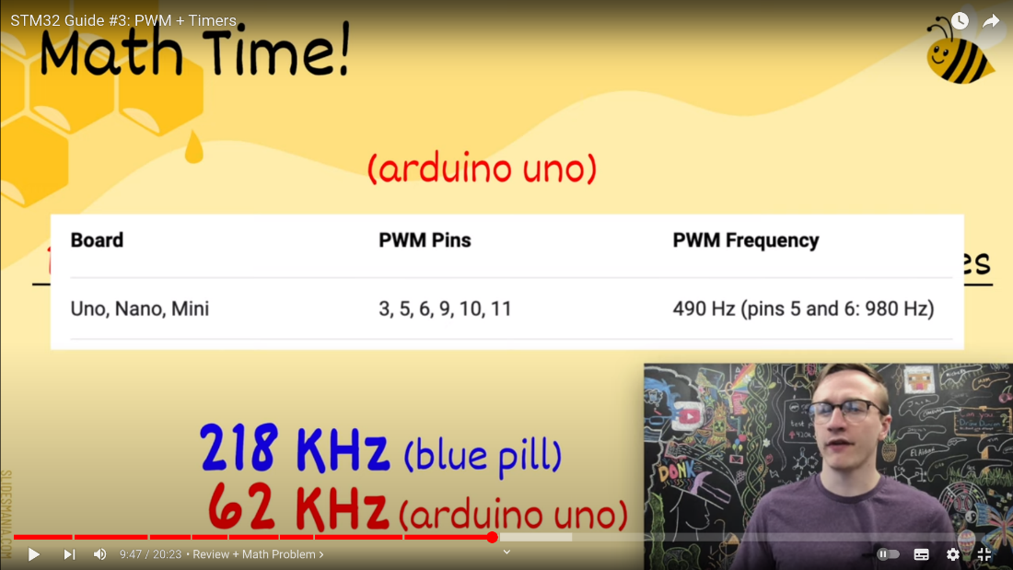

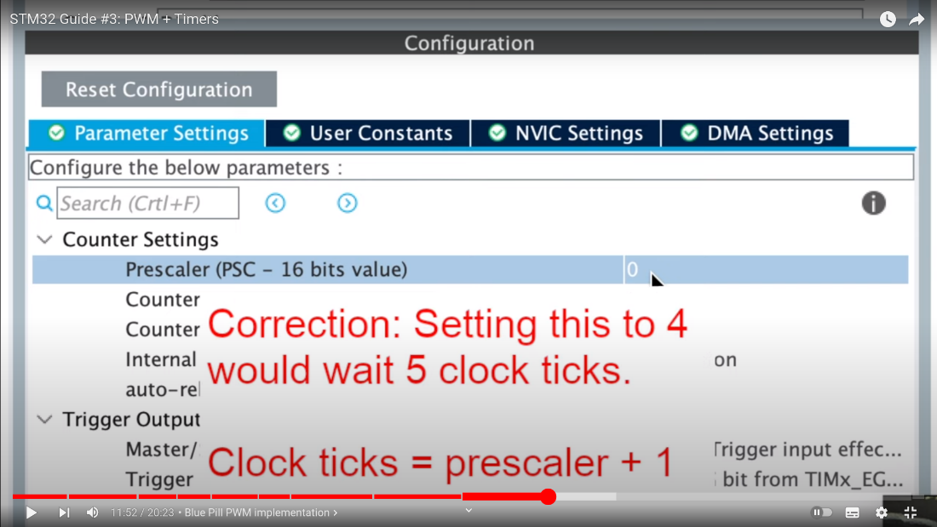

**Code for flashing**

╰─ st-flash write example.bin 0x08000000 ─╯

LED FADE

https://www.micropeta.com/video15

**Generate 600KHz Output**

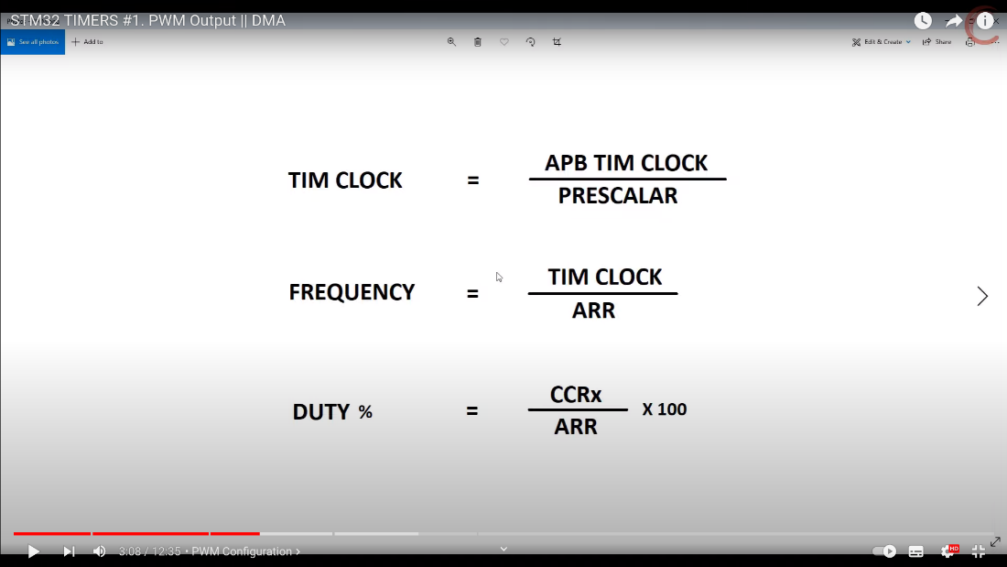

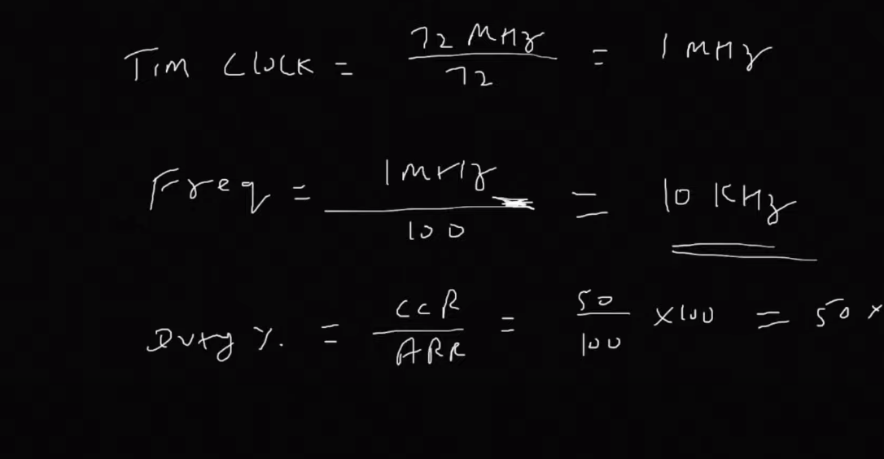

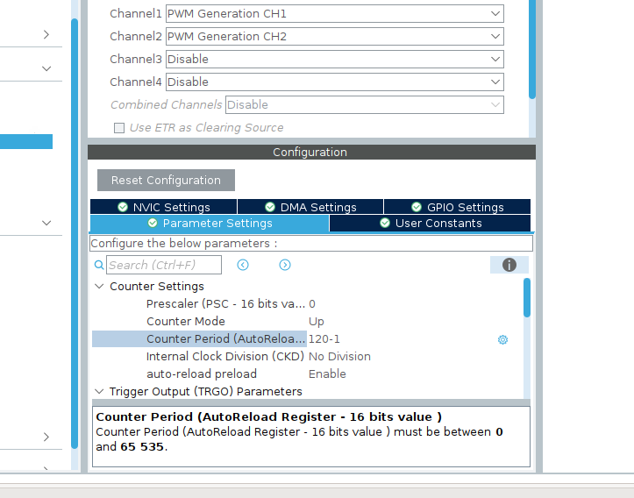



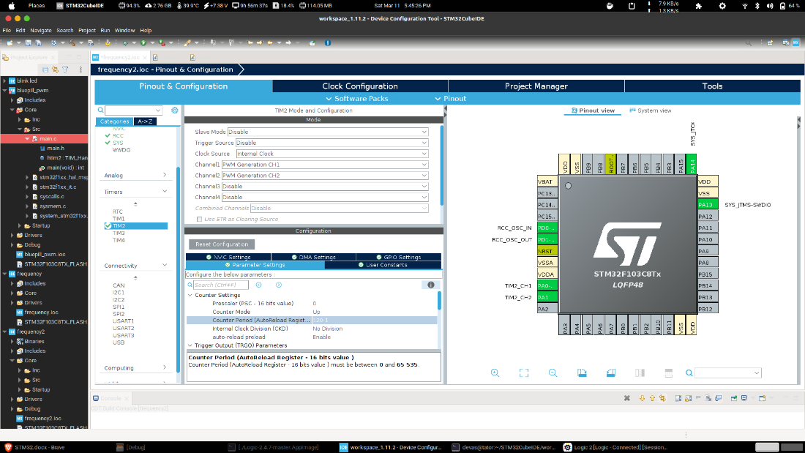

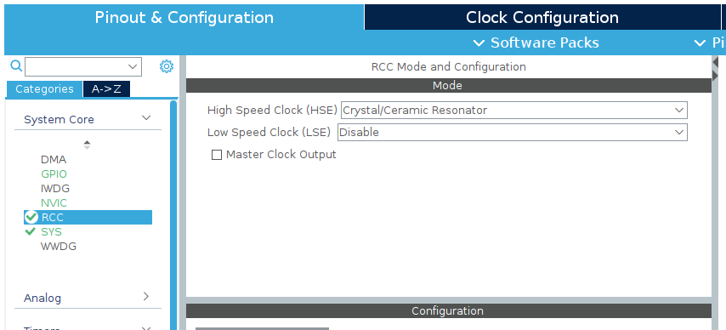

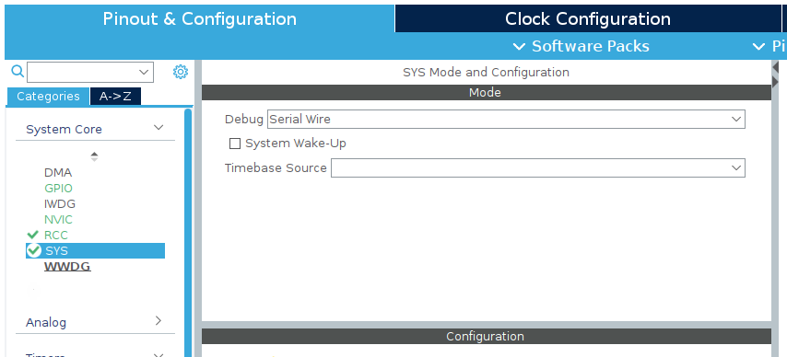

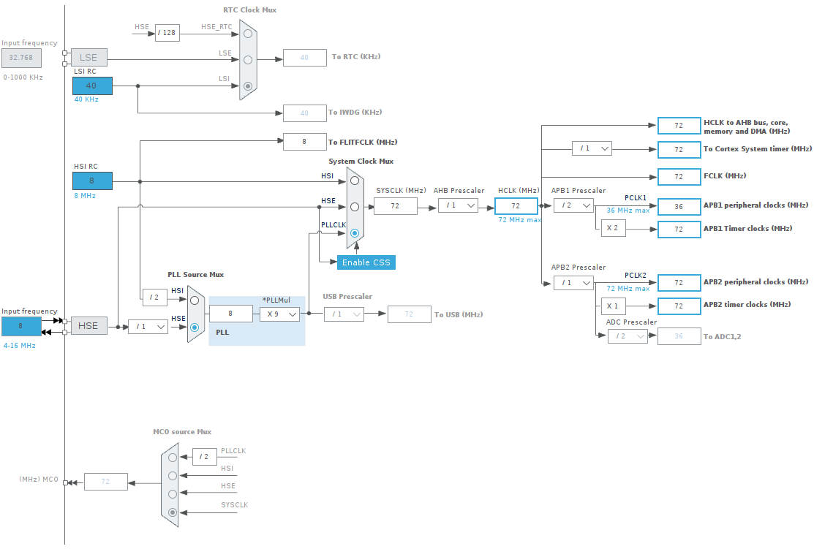

**Print in UART**

UART (Universal Asynchronous Receiver/Transmitter) is a hardware communication interface commonly used for serial communication between microcontrollers, computers, and other devices. It is a simple and reliable way to send and receive data between devices.

The UART consists of two main components: a transmitter and a receiver. The transmitter converts parallel data from the device into a serial data stream, and the receiver converts the serial data stream back into parallel data for use by the device. The communication between the transmitter and receiver is asynchronous, meaning that there is no clock signal to synchronize the data transfer. Instead, the receiver uses the start and stop bits of each byte to determine when a new byte of data is being sent.

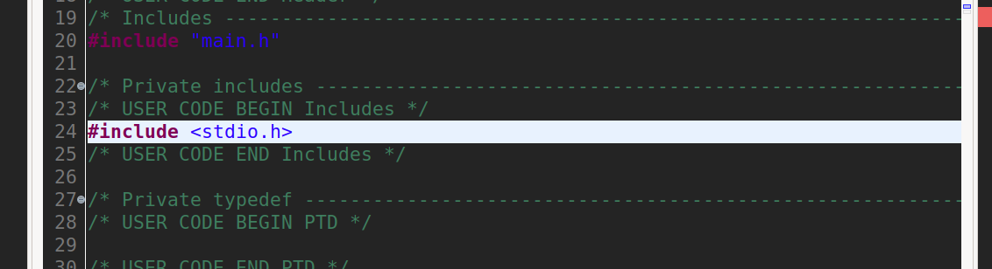

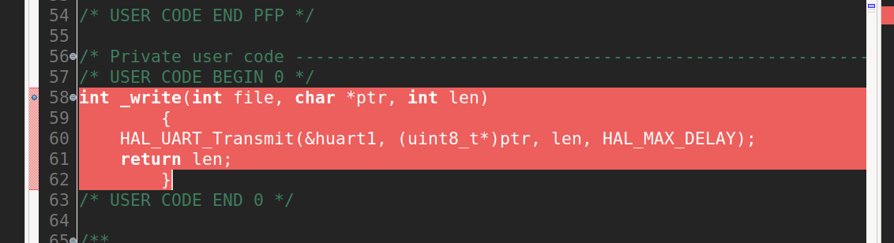

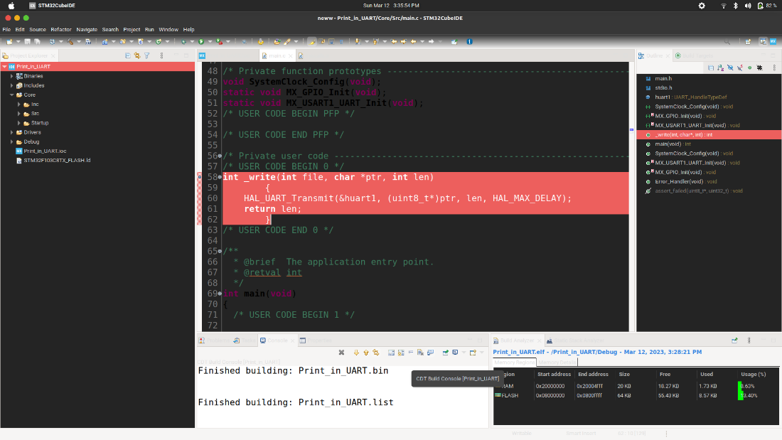

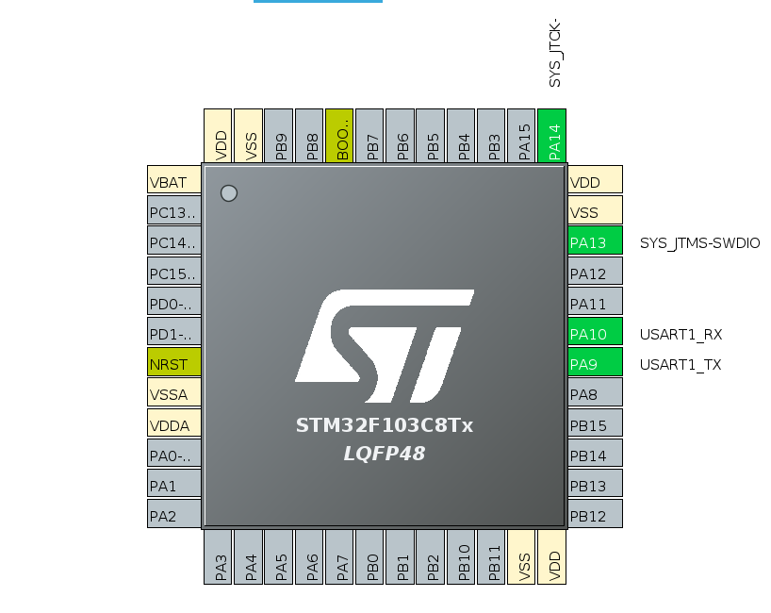

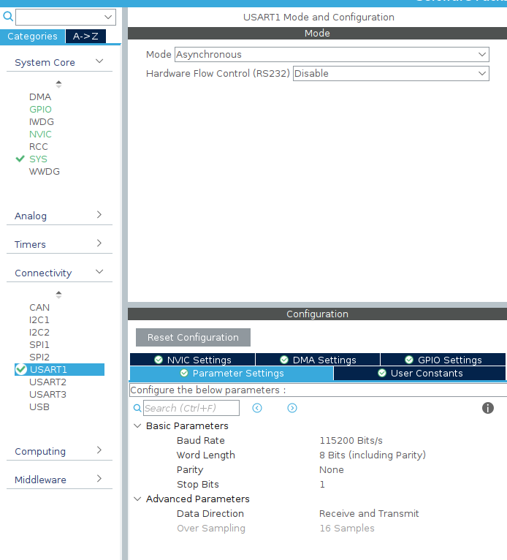

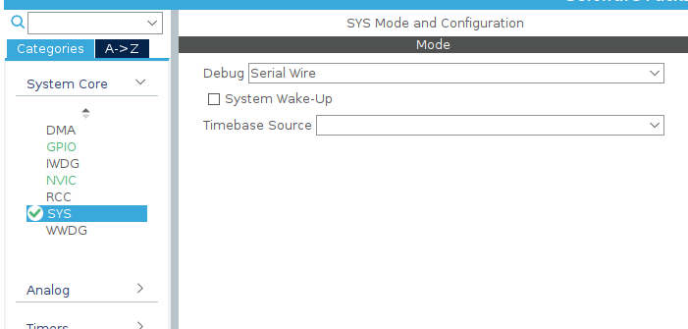

**Code explanation in this case**

This code appears to be a function definition for the **_write** function. This function is typically used to redirect the standard output from the printf function to a specific output device, such as a UART interface.

In this code, the function takes three arguments: **file**, which is an integer that represents the file descriptor; **\*ptr**, which is a pointer to the data to be written; and **len**, which is an integer that represents the length of the data to be written.

The function body consists of a single line that calls the **HAL_UART_Transmit** function. This function is part of the HAL (Hardware Abstraction Layer) library provided by STMicroelectronics for their STM32 microcontrollers. It takes four arguments: the UART handle (**&huart1** in this case), a pointer to the data to be transmitted (**(uint8_t*)ptr**), the length of the data (**len**), and the maximum delay time (**HAL_MAX_DELAY** in this case).

The **HAL_UART_Transmit** function is used to transmit the data over the UART interface. It waits until the transmission is complete before returning. Finally, the function returns the length of the data that was written.

This code is specifically designed for use with STM32 microcontrollers and the HAL library provided by STMicroelectronics. However, the basic concept of redirecting standard output to a UART interface can be applied in other contexts as well.

**Asking user what is your name and respond with “Hello,<user entered name>”]**

[what is your name2 code](https://amritauniv-my.sharepoint.com/:u:/g/personal/am_en_u4eac22024_am_students_amrita_edu/ETEIeitnDhZFmUkkBUU2VRABH_AyVNNmRptPzEO83_rt_A?e=jxbHgn)

**UART communication with user in serial monitor(password comparing)**

[flag v3](https://amritauniv-my.sharepoint.com/:u:/g/personal/am_en_u4eac22024_am_students_amrita_edu/EQU8k9g2GCNCrtfS7XF95xUBspKgMh9xKlj73fmlaTFKXw?e=Cyt5lf)

To do this task I need to improve my c language coding

***changing bitrate and adding parity bit***

I don’t know what is bitrate and parity bit

# Watch a video on youtube- **How to send a self-correcting message (Hamming codes)**

[How to send a self-correcting message (Hamming codes)](https://youtu.be/X8jsijhllIA)

[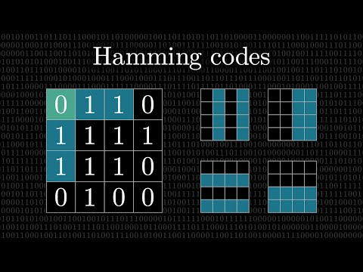](https://youtu.be/X8jsijhllIA)

**IMPORTANT WEBSITE**

[**https://www.3blue1brown.com/**](https://www.3blue1brown.com/)

I watched a few videos about what is **UART**

Found the dataframe of UART

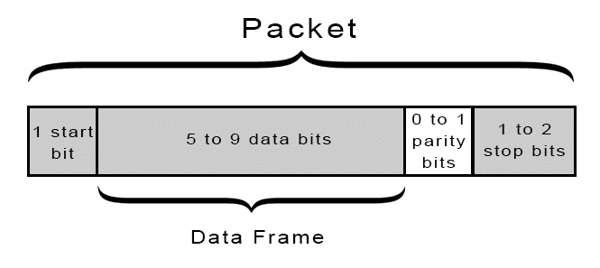

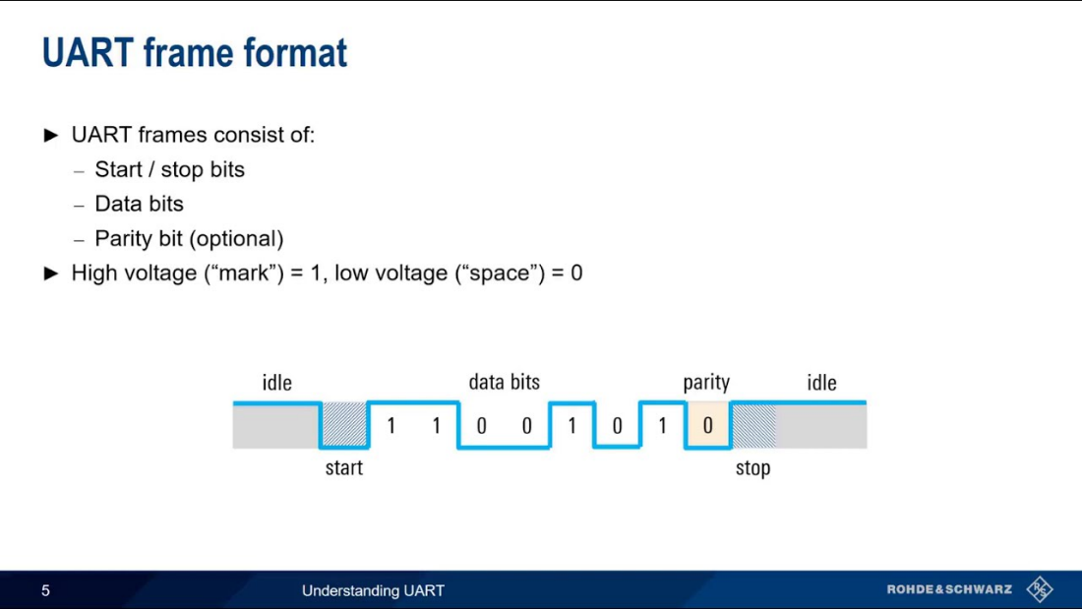

Then I changed the configuration settings and tried to figure out the datastructure uusing **Logic analyzer**

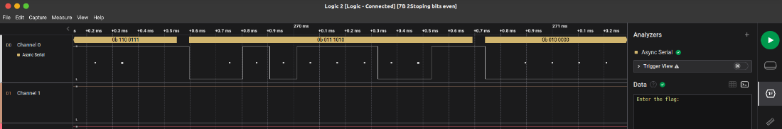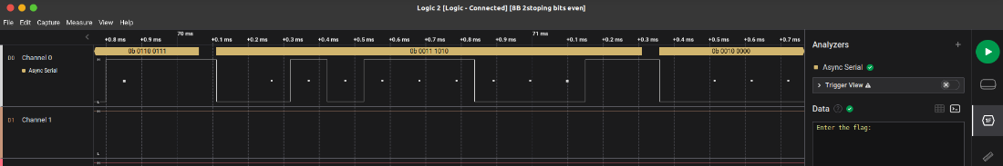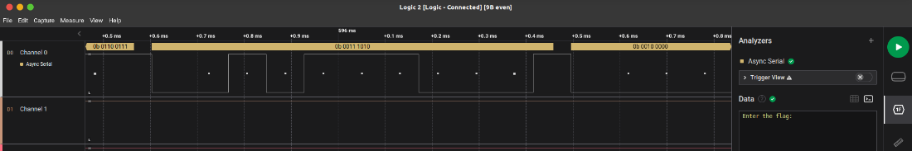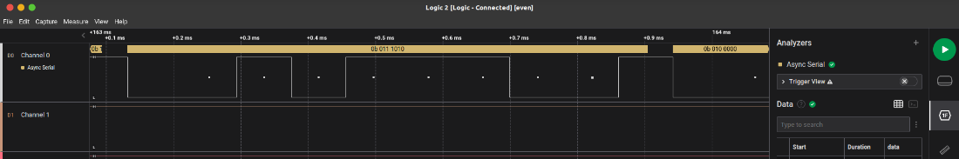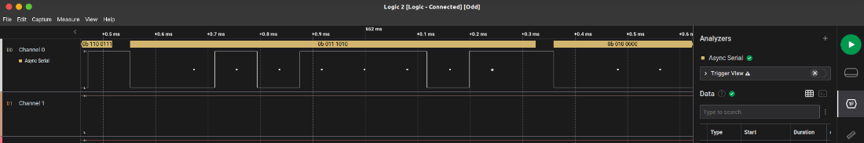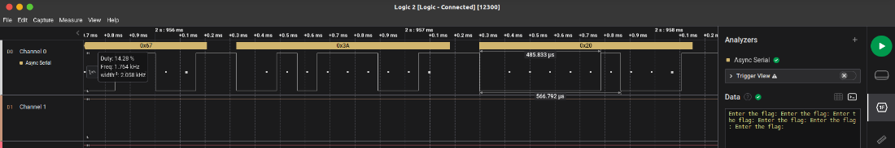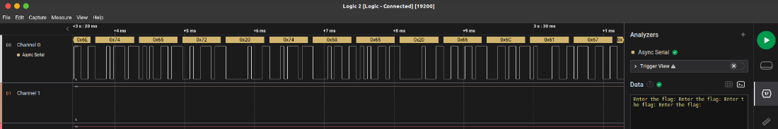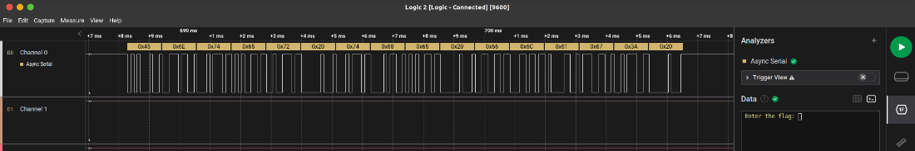

Now I understood about these structure

Ive also learnt to change baud rate by changing in the configuration settings and tried in logic analyzer and it got worked.

[web view](https://sway.office.com/yJdz4xPh9D6u08v2)

[](https://sway.office.com/yJdz4xPh9D6u08v2)